The relationship between state capacity and the proportion of a country’s land area that is under environmental protection

- A scatterplot showing the relationship between the proportion of protected land areas and state capacity score.
Answer:
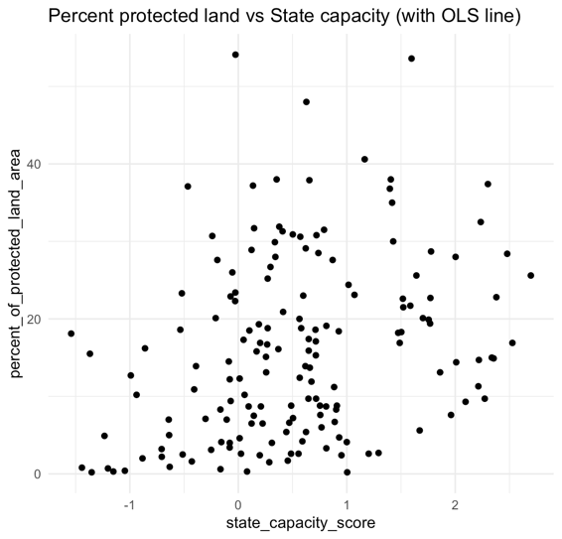
The data show a weak positive relationship:
- As state capacity increases, the percent of land under protection tends to increase slightly.
- The upward trend is subtle, not strong—which is also reflected in the small R² (about 0.09 in the regression later).
This means that countries with stronger state capacity generally tend to protect more land, but capacity alone is clearly not a strong predictor.
The scatterplot is very diffuse:
- Points are widely spread vertically at almost every level of state capacity.
- For the same capacity score, the percent of protected land can range from near 0% to over 40%.
This suggests that many other factors influence land protection and that the relationship between these two variables is high-variance and noisy.
The following syntax was used to create scatterplot:
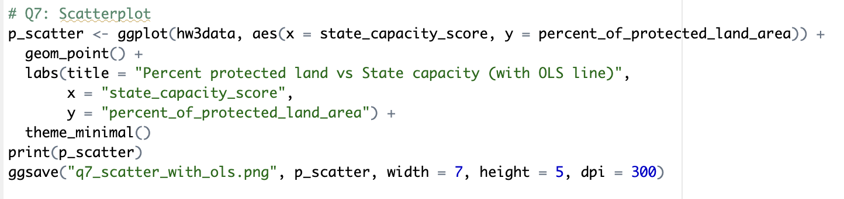
- A regression of percent of protected land area (dependent variable) on the state capacity score (independent variable) and plot the regression line atop scatterplot.
Answer:
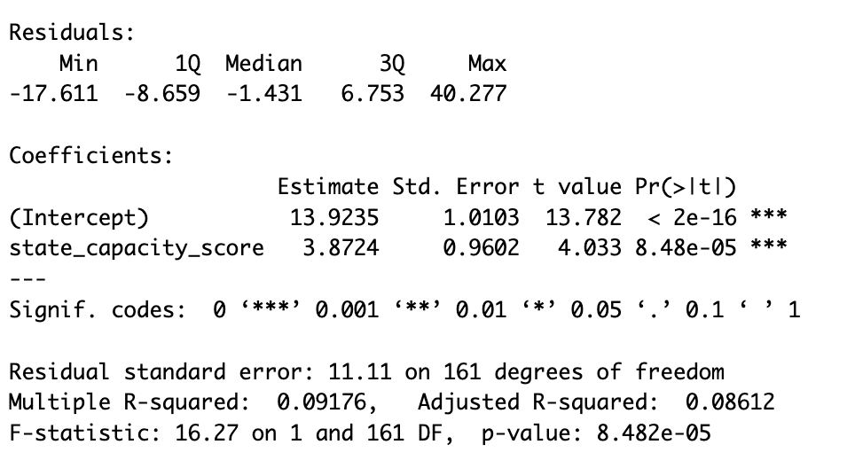
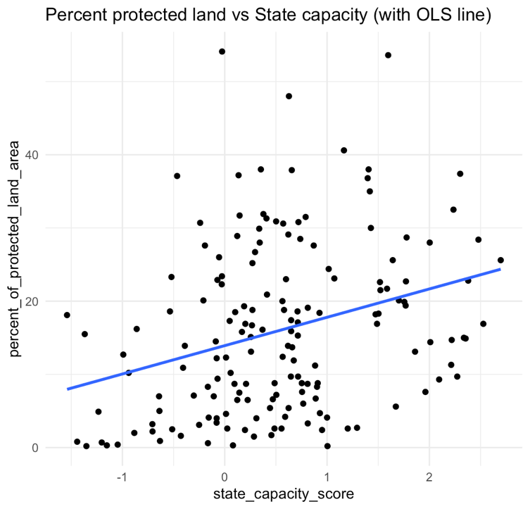
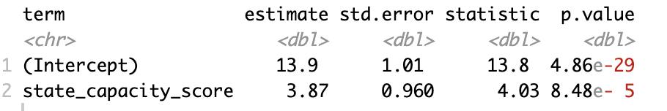
The following syntax was used to estimate regression:
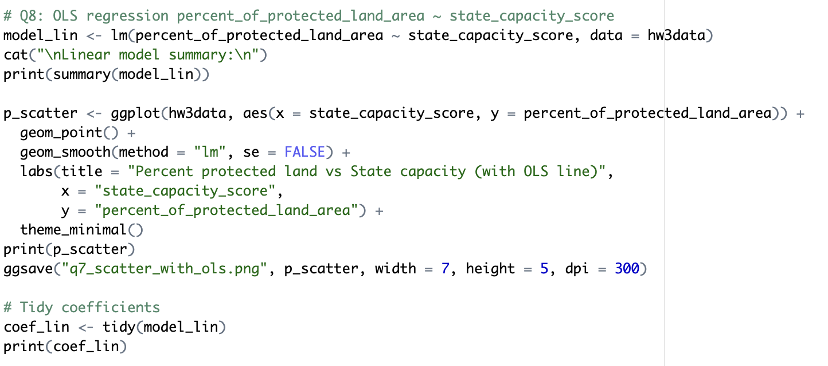

- Report the estimated intercept and coefficient, interpret them, and explain if the estimated intercept is substantively meaningful in this context.
Answer:
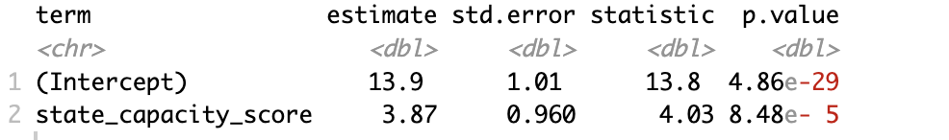

Estimated intercept: 13.9235
Estimated coefficient on state_capacity_score: 3.8724
∴ Interpretation: A one-unit increase in state capacity (which corresponds to a one-standard-deviation increase because the variable is standardized) is associated with an estimated 3.87-percentage-point increase in the percent of protected land area.
The intercept of 13.92 represents the predicted percent of protected land for a state with a capacity score of 0, which corresponds to an average-capacity state. Because the predictor is standardized, this value is substantively interpretable: it provides an estimated baseline level of protected land for a typical state.

- Calculate the predicted percent of land under protection in a country with a state capacity of 3. To what extent should we assign substantive meaning to this predicted value?
Answer:
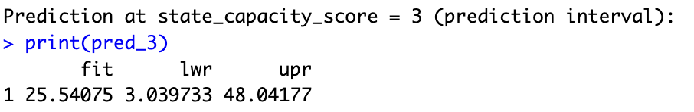

$$\hat{y} \left(x=3\right)=\hat{β_{0}}+\hat{β_{1}}\left(3\right)=13.9235+3.8724×3=25.5407$$

The model predicts ≈ 25.54% of land is protected when state_capacity_score = 3.
The output also reports a prediction interval (presumably a 95% prediction interval):
lower = 3.0397, upper = 48.0418. That means: for a new country with capacity = 3, the model predicts its percent protected will most likely fall somewhere between ≈ 3.04% and 48.04% (95% PI), reflecting both uncertainty in the mean and the individual outcome variability.
The following syntax was used to find the prediction as asked:
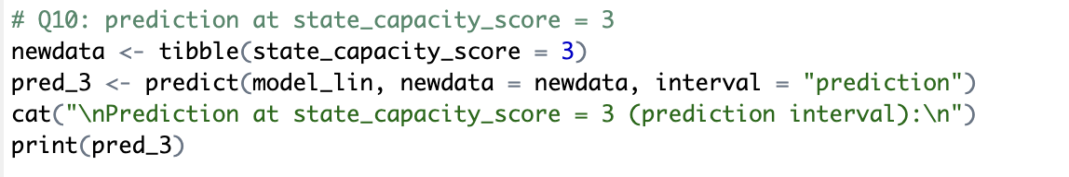

- Estimate from the regression.
Answer:
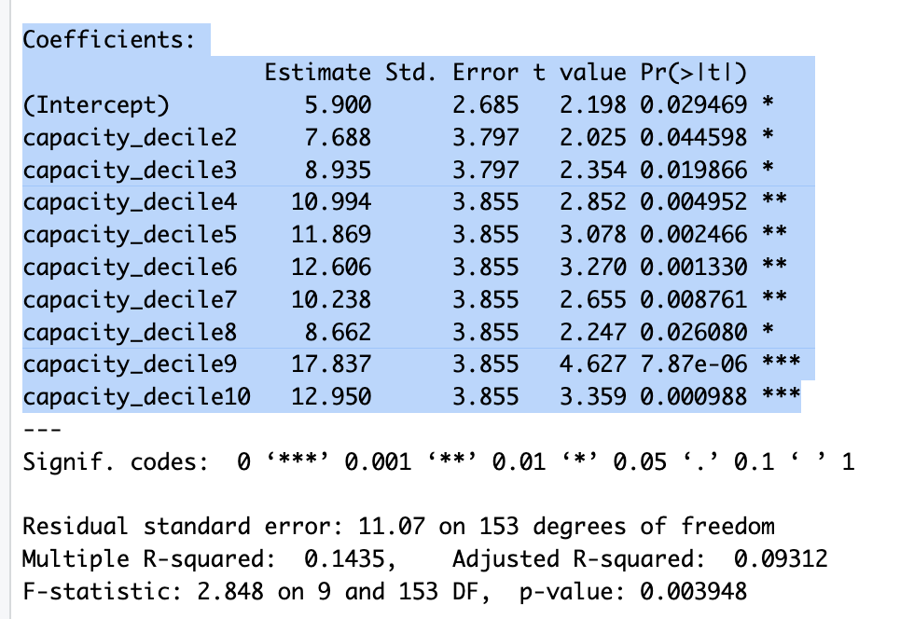

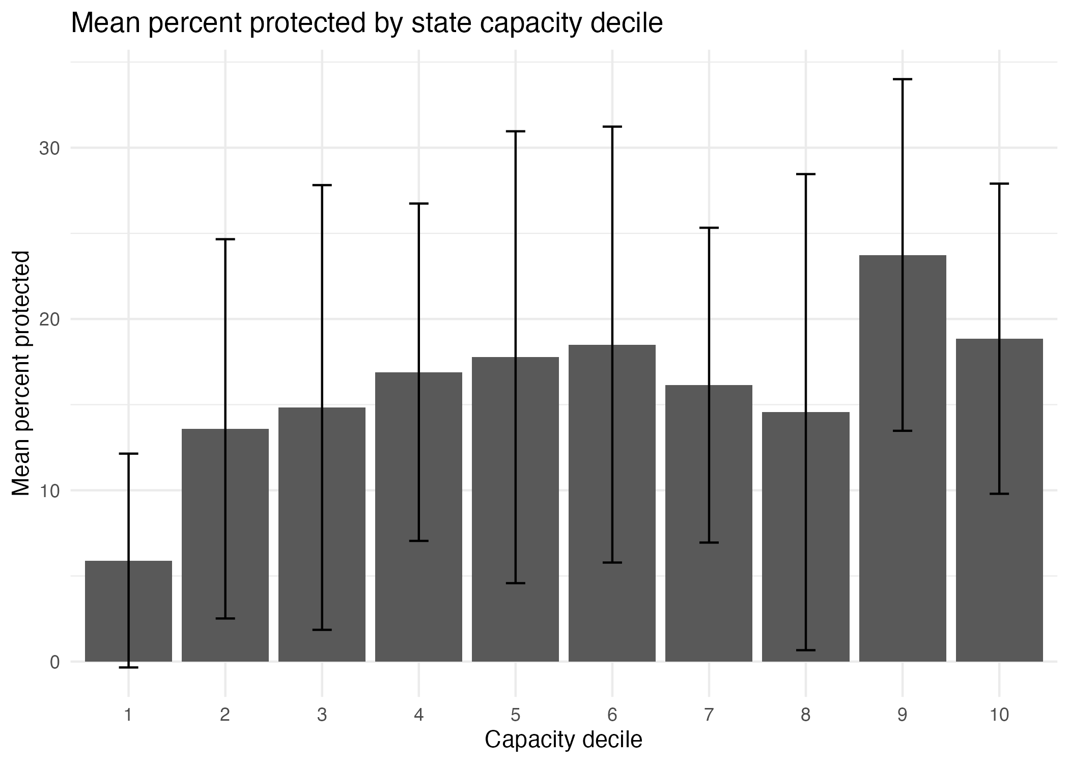
The following syntax was used to estimate regression:
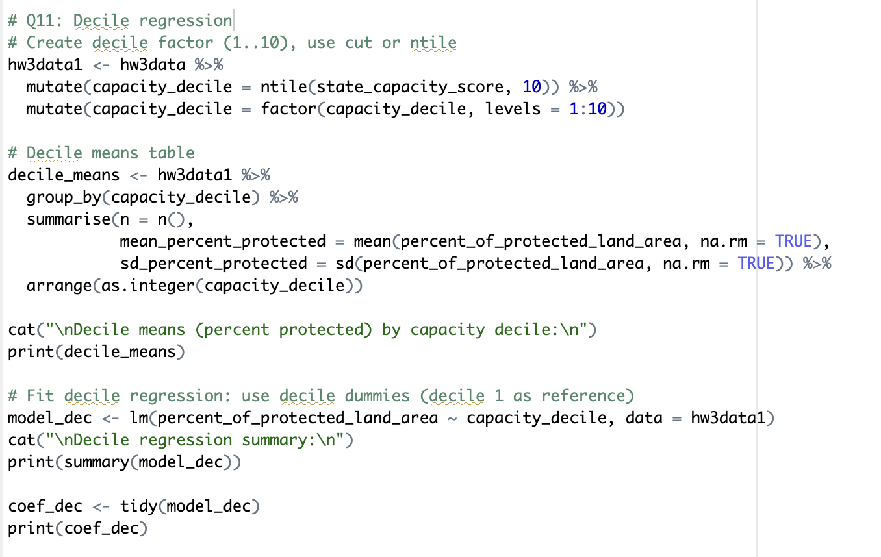

- Which regression—the one based on the single variable for state capacity or its transformation to deciles—seems to provide better predictions of annual earnings within the sample?
Answer:
Indicator | Linear Model | Decile Model
R-squared | 0.091758 | 0.143505
Adjusted $R^{2}$ | 0.086117 | 0.093123
Residual SE | 11.111325 | 11.068652
∴ To compare the predictive performance of the linear and decile models, I examined their R-squared values, adjusted R-squared values, and residual standard errors. The decile model achieves a higher R² (0.1435 vs. 0.0918), indicating that it explains more of the variation in percent protected land. However, because the decile model includes nine dummy variables, R² alone exaggerates its improvement.
Looking instead at adjusted R², which penalizes model complexity, the decile model still performs slightly better (0.0931 vs. 0.0861). This means that even after accounting for the increase in parameters, the decile model captures real nonlinear variation that the linear model misses, though the gain is modest.
The residual standard error also decreases slightly in the decile model (11.0687 vs. 11.1113), showing a small reduction in average prediction error.
Overall, the decile model fits the data better in-sample, but only by a small margin. The improvements in adjusted R² and RSE are minor, suggesting that the added complexity may be partially capturing noise rather than strong nonlinear structure. Thus, while the decile model has better in-sample performance, the linear model remains more parsimonious and may generalize better out-of-sample.
The following syntax was used to compare linear and decile model:
